# Chap 18

**18-1 Define competitive advantage. How do companies go about finding their competitive advantage? (AASCB: Communication)**

An advantage over competitors gained by offering consumers greater value. Conduct customer surveys to see why consumers choose your company. It could be that you are able to offer a comparable service at a lower price, in which case it is time to review your processes to determine where you reap cost savings. Once a potential competitive advantage is identified, find out how rare it is.

**18-2 How does a company identify its competitors? What do marketing managers want to know about the companies identified as competitors? (AACSB: Communication; Reflective Thinking)**

Identifying the company’s competitors

Assessing competitors’ objectives, strategies, strengths and weaknesses, and reaction patterns

Selecting which competitors to attack or avoid

Identifying competitors isn’t as easy as it seems. For example, Kodak saw other camera film makers as its major competitors. But its real competitors turned out to be the makers of digital cameras that used no film at all. Kodak fell behind in digital technologies and ended up declaring bankruptcy.

**18-3 Describe the strategies that a market follower might adopt, and explain why they might never challenge the market leader. (AACSB: Communication)**

There are 4 strategies of Market followers.

* Adapter.
* Imitation.
* Cloner.
* Counterfeiter.

Not all runner-up companies want to challenge the market leader. The leader never takes challenges lightly. If the challenger’s lure is lower prices, improved service, or additional product features, the market leader can quickly match these to defuse the attack. The leader probably has more staying power in an all-out battle for customers.

**18-4 How can a market leader retain their position against competition? (AACSB: Communication)**

To remain number one, leading firms can take any of three actions. First, they can find ways to expand total demand. Second, they can protect their current market share through good defensive and offensive actions. Third, they can try to expand their market share further, even if market size remains constant.

**18-5 Is there no alternative for a business than market orientation? (AACSB: Communication; Reflective Thinking)**

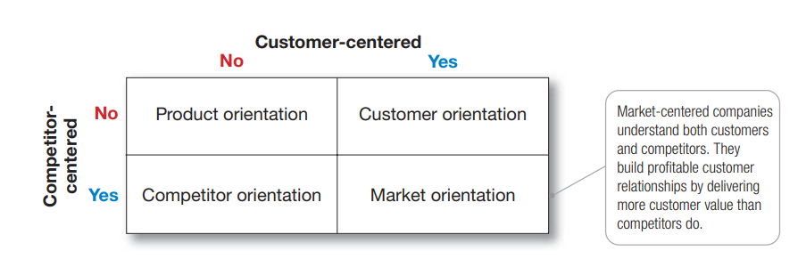

**18-6 Form a small group and conduct a customer value analysis for your college or university. What are the strong and weak competitors? For the strong competitors, what are their vulnerabilities? (AACSB: Communication; Reflective Thinking)**

If a competitor only sells one product, this may be seen as a weakness as the competitor will have limited market reach. In contrast, if a competitor has a large product range, this could be seen as a strength, as the competitor is likely to be able to target a wider range of customers.

# Chapter 13

**13-1 Define omni-channel retailing and explain its connection to shopper marketing.**

Today’s omni-channel buyers shift seamlessly across online and in-store channels throughout the buying process. They’ve gotten used to researching and buying anywhere, anytime— whether it’s in the store, online, on the go, or even online while in the store. To meet the needs of these omni-channel buyers, store retailers must master omni-channel retailing, integrating store and online channels into a single shopper experience

**13-2 How would you describe the key elements of a workable retail marketing mix?**

**Product**, **price**, **promotion**, and **place** form the four Ps of the marketing mix. These are the key factors that are involved in introducing a product or service to the public.

**13-3 Distinguish between a warehouse club and a factory outlet. What is distinctive about them?**

Warehouse club An off-price retailer that sells a limited selection of brand name grocery items, appliances, clothing, and other goods at deep discounts to members who pay annual membership fees

Factory outlet An off-price retailing operation that is owned and operated by a manufacturer and normally carries the manufacturer’s surplus, discontinued, or irregular goods

**13-4 Does a business need agents and brokers?**   
**13-5 In January 2017, UK retailer Tesco bought the wholesaler Booker. Why would they do this?**

The Commercial Agent provides a systematic control of relationship management, something that is vital in ensuring the duration of the company's contacts. The customer database is the capital that the Commercial Agent contributes to the business relationship with the companies it represents.

# Chap 12

**12-1 Compare and contrast upstream and downstream partners in a company’s supply chain. Explain why value delivery network might be a better term to use than supply chain.**

A company can’t go it alone in creating customer value. It must work within a broader network of partners to accomplish this task. Individual companies and brands don’t compete their entire value delivery networks do.

Upstream from the company is the set of firms that supply the raw materials, components, parts, information, finances, and expertise needed to create a product or service

Downstream marketing channel partners, such as wholesalers and retailers, form a vital link between the firm and its customers.

**12-2 Why is it often necessary and advantageous to have intermediaries in a marketing or distribution channel?**

**12-3 How would you distinguish between exclusive and selective distribution?**

exclusive distribution Giving a limited number of dealers the exclusive right to distribute the company’s products in their territories. Selective distribution The use of more than one but fewer than all of the intermediaries that are willing to carry the company’s products

**12-4 Name and describe the three strategies available when determining the number of marketing intermediaries.**

Intensive, exclusive and selective marketing intermediatories.

**12-5 List and briefly describe the major logistics functions. Provide an example of a decision a logistics manager would make for each major function.**

The major logistics functions are warehousing, inventory management, transportation, and logistics information management.

# Chap 11

**11-1 Name and describe the two broad new-product pricing strategies. When would each be appropriate? (AACSB: Communication)**

Market Skimming , Market penetration.

**11-2 Define product bundle pricing. Give examples where companies have used this pricing strategy. (AACSB: Communication; Reflective Thinking)**

Product sold in bundle

**11-3 What is promotional pricing, how is it used by sellers, and what are the risks? Give an example. (AACSB: Communication)**

Promotional pricing temporarily reducing prices to spur short-run sales.

**11-4 Discuss some situations that may prompt companies to initiate price cuts.**

Weakened economy. In such cases, the firm may aggressively cut prices to boost sales and market share.

But cutting prices in an industry loaded with excess capacity may lead to price wars as competitors try to hold on to market share.

**11-5 Discuss some pricing policies across channel levels with the ultimate aim of building strong and lasting customer relationships.**

Major public policy issues in pricing take place at two levels: pricing practices within a given channel level and pricing practices across channel levels.

1. profit margins should be adequate for channel members, (2) margins offered to different classes of channel members should vary in proportion to the functions the channel members perform, (3) margins should be competitive with those of rival brands, (4) special arrangements that result in either an increase or decrease in services rendered should be reflected in the margins, (5) the manufacturer should conform to conventional norms for margins in the trade, (6) variations in margins on different models should be logical, (7) if price points exist at the wholesale/retail levels they should be recognized and prices set to meet these price points, and (8) variations in prices by a manufacturer for different products in its line should be associated with visible or identifiable differences in its line.

# Chap 07

**7-1 How would you describe the key differences between differentiation and positioning? Do businesses use both techniques?**

At the same time that a company is answering the first simple-sounding question (Which customers will we serve?), it must also be asking the second question (How will we serve them?).

Product position is the way a product is defined by consumers on important attributes—the place it occupies in consumers’ minds relative to competing products.

**7-2 How is demographic segmentation used in consumer markets? Provide an example where marketers have used demographic segmentation.**

Dividing the market into segments based on variables such as age, life-cycle stage, gender, income, occupation, education, religion, ethnicity, and generation.

**7-3 What is the value of intermarket segmentation for global businesses?**

Intermarket (cross-market) segmentation Forming segments of consumers who have similar needs and buying behaviors even though they are located in different countries.

**7-4 There are many ways to segment a market, but not all segmentations are effective. Explain the five requirements for effective market segmentation.**

**Explain the differences between differentiated and undifferentiated marketing. Can a business effectively use both strategies?**

undifferentiated (mass) marketing A market-coverage strategy in which a firm decides to ignore market segment differences and go after the whole market with one offer. Differentiated (segmented) marketing A market-coverage strategy in which a firm targets several market segments and designs separate offers for each.

**How can a company gain competitive advantage through differentiation? Describe an example of a company that illustrates each type of differentiation discussed in the chapter**

To build profitable relationships with target customers, marketers must understand customer needs and deliver more customer value better than competitors do. To the extent that a company can differentiate and position itself as providing superior customer value, it gains competitive advantage.